Use your Letter Head or Jane Charles, R.Ph. &
Pharmacy Name YOUR LOGO HERE John Charles, R.Ph.
Phone ____________ 777 Feelgood Lane
Fax ______________ City, ST 30039
www.YourURL.com

courtesy of

Pharmacy Name (logo)

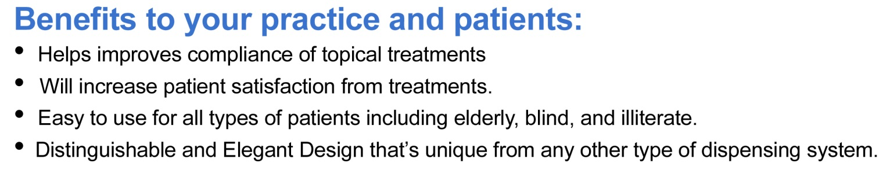
Please call Pharmacy Name (logo) at ________________ for more information.

