- PURPOSE
  - The purpose of this procedure is to outline the use and maintenance of the Topi-Filler™ Filling Station.
- SCOPE
  - This procedure applies to all personnel who utilize the Topi-Filler™ Filling Station at the Pharmacy.
- PERSONNEL
  - Personnel involved in filling Topi-CLICKs or other topical medication dispensers.
- REFERENCE
  - Instruction Manual
  - Figure 1: Topi-Filler™ Filling Station
- DEFINITIONS
  - N/A
- FREQUENCY
  - N/A
- EQUIPMENT/MATERIALS
  - Topi-Filler™ Filling Station
- GENERAL INFORMATION
  - Refer to instruction manual for troubleshooting.
- PROCEDURES
  - Set-Up: Topi-Filler™ Filling Station (see Figure1.)
    - Adjust Brake, located on the right side BELOW dispensing handle knob, to preferred tension. Loosen tension by turning forward; tighten by turning backward. The brake keeps the push rod from falling down when there is no jar in the filling station. Therefore, use the least amount of braking needed to reduce the force required for pulling the push rod assembly up when removing a jar.
    - Attach Quick Dispensing Rod Adapter onto the end of the Dispensing Rod.
    - Adjust EMP Jar brace to fit EMP jar by twisting the Brace Locking Screw forward then lowering/ raising the brace as needed. Re-tighten the Brace Locking Screw by twisting backward.

  - Use-Topi-CLICK Filling Station
    - Select topical dispenser and preparation-filled EMP jar.
    - Attach dispensing nozzle to EMP jar cover. Use of a nozzle stopper is advised for thin preparations.
    - Raise Dispensing Rod to upmost position.
    - Place sample-fill EMP jar onto the Topi-Filler™ Filling Station such that the nozzle is pointed downward and the EMP jar cover is resting on the notched dispensing shelf.
    - Lower Dispensing Rod so that the Adaptor is resting against the plunger of the EMP jar. Be careful to not push the plunger, as it will cause the preparation to begin dispensing prematurely.
    - Remove the nozzle plug and hold topical dispenser directly underneath the nozzle.
    - Pull down on the Filling Station Handle to commence filling.
      - To reduce air bubbles, hold dispenser so that the nozzle is as close as possible to the bottom of the container.
      - Rotate dispenser as preparation is being dispensed to fill in gaps and air pockets.
      - Sporadically, cease the filling process by releasing the Handle, and tap dispenser against table top to remove any air bubble.
      - Continue filling and sporadic tapping until dispenser is filled.
    - Release Handle.
    - Raise Dispensing Rod to upmost positon.
    - Plug the Nozzle.
    - Remove EMP jar from Filling Station.
    - Assemble and prime dispenser.

9.3 Cleaning/Maintenance

    - Wipe down Topi-Filler™ Filling Station daily with damp towel and/or mild non-abrasive cleaner.
    - Do not use sharp objects or scouring agents to clean the unit.
    - Do not immerse the unit in water.
    - Clean base, Adapter, Dispensing Rod, Handle, or other contaminated surfaces in the event of overflow or leakage before spilled preparation dries.

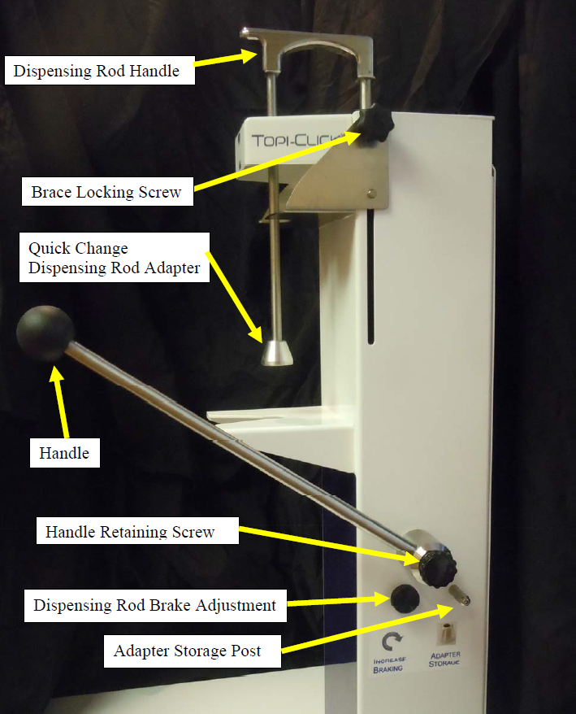
Figure 1: Topi-Filler™ Filling Station

- ATTACHMENTS
  - N/A
- HISTORY
Version Number | Date Effective | Description of Change | Change Request Number
1.0 | 07/01/15 | New SOP.

