PHARMACY NAME HERE  Phone: ###-###-####  Fax: ###-###-#### | YOUR LOGO HERE | Streetname  City state zip
Your website here.com
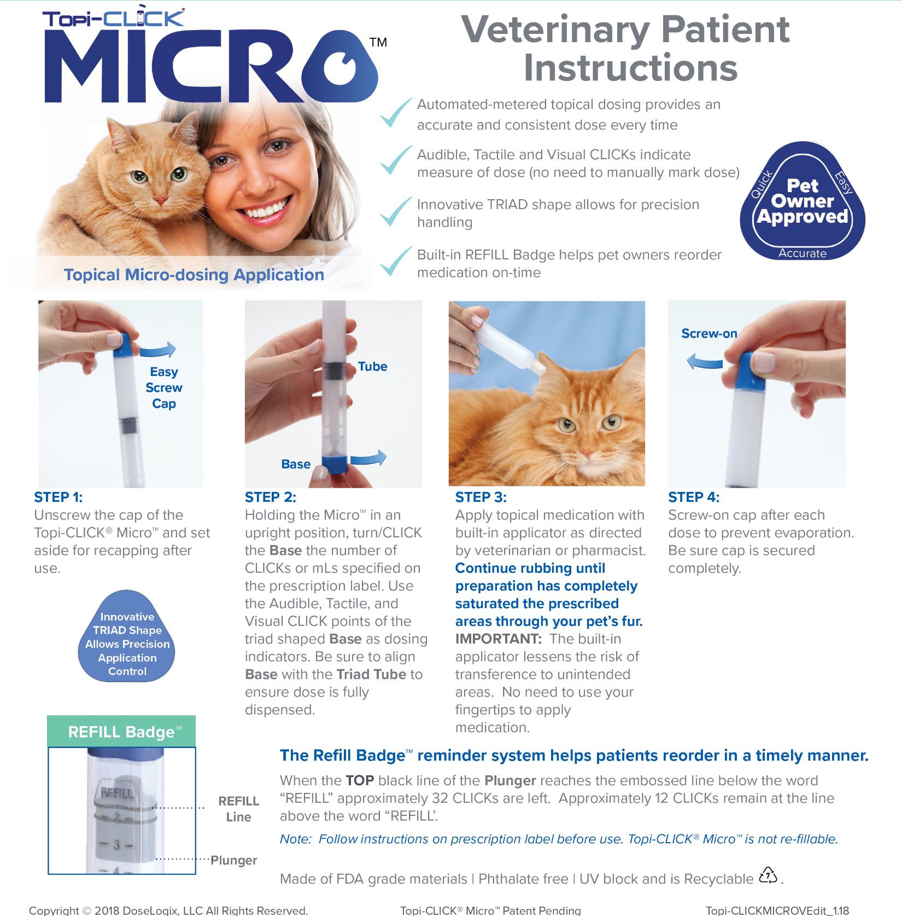
Pharmacy/Vet Name | ###-###-#### | email@email.com | http://www.yourwebsitehere.com

